A project report on

VRCar

*Submitted by*

Manik(15CSU109),

Pallak(15CSU144),

Vinay(15CSU258),

and Vineet(15CSU259)



Department of CSE & IT

The NorthCap University

Gurugram

A project report on

VRCar

*Of*

**Bachelor of Technology**

**in Computer Science Engineering and Information Technology**

*by*

Manik(15CSU109),

Pallak(15CSU144),

Vinay(15CSU258),

and Vineet(15CSU259)

Under Supervision of

Ms. Jyotsna Singh



Department of CSE & IT

The NorthCap University

Gurugram

**CERTIFICATE**

This is to certify that the Project Report entitled, “**VRCar**” submitted by “**Manik, Pallak, Vinay and Vineet”** to **The NorthCap University, Gurugam, India,** is a record of bonafide Project work carried out by him/her under my supervision and guidance and is worthy of consideration for the award of the degree of **Bachelor of Technology** in **Computer Science Engineering and Information Technology** of the Institute.

Dr. Jyotsna Singh

Date: 21/2/18

**ACKNOWLEDGEMENT**

We would like to express our sincere gratitude to our supervisor, Dr. Jyotsna Singh, whose contribution in stimulating suggestions and encouragement as well as her active guidance helped us to make progress on our project especially in writing this report. We would like to extend our deepest appreciation to all those who provided us their support and helped us in this endeavor.

We are indebted to our teachers and friends who have provided us with the knowledge and encouragement to help us bring in our best to this project.

**ABSTRACT**

Virtual Reality is a rapidly developing technology that has found itself being employed in various domains. VR provides an immersive experience by filling the entire field of view with an image where the head movements control where and what the user sees. This project is going to bring a virtual reality experience to small scale robotic vehicles.

There are places in the world or sensitive projects where it is not safe for humans to go themselves but require devices controlled from a distant location to give the relevant and required information. We propose to bring an immersive experience to make information gathering more efficient and lifelike. The main focus of this project is to create an economical system that combines a robotic car with integrated VR so that such devices can be used widely in such fields. The project will be having many open source designs incorporated into it. The project will be using an Arduino and a Raspberry Pi to perform the functions it’s meant to. Further a mobile app will be developed which will offer many device settings and information (such as battery information), the mobile app will also be used to display the VR video, where one could the mobile phone as the VR headset.

**CONTENTS**

Certificate …………………………………………………………………………..i

Acknowledgements..……………………………………………………………….ii

Abstract………………….……………….…………….…….….….….….….……iii

List of Tables …...……….………………………………………………………...iv

List of Figures ….…………………………………………………………………iv

List of Symbols and Abbreviations ………….……………………………………iv

1.Introduction.….………………………….……………………………………….1

* System Objective…………………………………………………………….1
* Market Landscape…………………………………………………………...1

2.System Design……………………………………………………………………2

* Hardware Interfaces…………………………………………………………2
* Software Interfaces…………………………………………………………..3

3. Implementation…………………………………………………………………..3

4.Constraints and Problems

* Design and Implementation Constraints……………………………………4
* Safety Issues…………………………………………………………………4
* Security Issues……………………………………………………………….4

5.Milestones………………………………………………………………………...5

6.References………………………………………………………………………...6

7.Glossary…………………………………………………………………………..6

**LIST OF TABLES**

Table 1 Major Milestones……………………………………………………..4

**LIST OF FIGURES**

Figure 1.1 Figure depicting VR headsets with smartphones placed inside……..1

Figure 2.1 Figure depicting the UML Use-Case diagram………………………3

Figure 4.1 Figure depicting latency and lag……………………………………..4

**LIST OF SYMBOLS AND ABBREVATIONS**

|  |  |
| --- | --- |
| **Abbreviation** | **Definition** |
| VR | Virtual Reality |
| HTTP | Hyper Text Transfer Protocol |
| IOT | Internet of Things |
| MOSFET | Metal-Oxide-Semiconductor Field-effect |
| MTP | Motion to Photon Latency |

1. **Introduction**

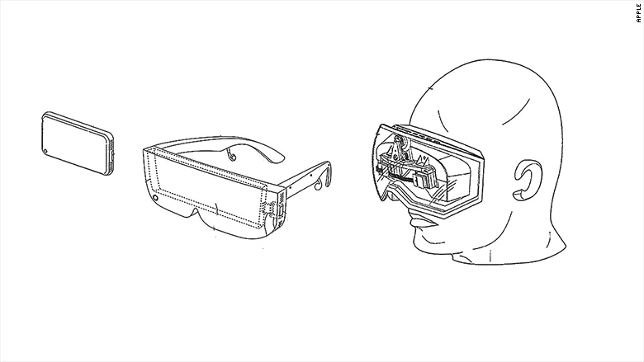There are a variety of applications that require quick and real time action-response in the world of robots. We require rapid information with the most meticulous observations from the robots sent in the remote areas we cannot reach ourselves. This project proposes a way to make the user controlling the robot to experience those remote areas like he was there himself. Virtual Reality(VR) is no longer a part of science fiction or something that gets battle around in laboratories. VR focuses on creating an interactive and immersive experience that engages the body and mind. This project will utilize virtual reality for just this: an immersive and interactive experience.

Figure 1.1: VR headset and smartphone

The project will be implementing hardware that will be able to broadcast a video feed from the dual cameras on board to a VR Headset. Further a mobile app to interact with the robotic car will be developed.

**1.1 System Objective**

This product in basic terminology is a Robotic Car that has VR implementation build into it. The main aim for this project is to create the hardware and the software required for the car. We aim to select optimum hardware such as microcontrollers, cameras and other parts for best possible performance. Software a VR headsets will be developed along the car which would let you interact with the car.

**1.2 Market Landscape**

We currently have identified a group of people could benefit or enjoy the product being developed by us if deployed in their workflows.

**Indented Audience**

* Gamer

Gamers can use the project to simulate a game environment in real life, for example: real life racing games between multiple similar cars where the gamer would have a more immersive and a real physical experience.

* Scientist

Scientists would be able to use to this explore alien or not easy to reach places with an immersive experience and further produce data for further research by adding customized sensors or add-ons as the designs will be open source.

* Differently Abled People

Differently abled can experience the world around them with little to no movements on their part

1. **System Design**

**2.1 Hardware Interfaces**

To develop a system like this we had to decide among a lot of hardware selection and design the hardware and the circuitry. We needed to decide on the following fronts before continuing:

1. Microcontroller to drive the car.
2. On-Board computer to handle VR related tasks.
3. Sensors to provide various physical data to manage the virtual reality.
4. The Cameras to actually record and send the video.

We’ve decided upon the following:

1. Arduino nano to function as the brain of the car, manage the driving functionality of the vehicle
2. Raspberry Pi as the on-board computer to handle the incoming sensor data and further interact with the VR.
3. Mobile Phones, most phones usually have a gyroscope, accelerometer and various other sensors. Further we decided on using the mobile phone as the VR headset too, that means we’ll be developing a mobile app to send sensor data to the car and to receive and display the VR video for the user.
4. We’ve yet to decide the cameras.

Going further, the circuitry of the car includes a lot of minute stuff such as, 12v DC motors, MOSFET transistors, on-board battery, battery controller, etc.

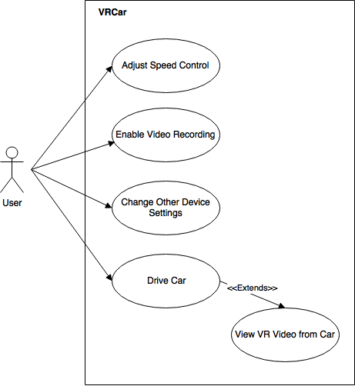

Figure 1.1: Use-case Diagram

**2.2 Software Interfaces**

* The Mobile software will provide the sensor data to the car hardware.
* HTTP is a publish-subscribe based messaging protocol. The Video transmission will be done  over HTTP on a local network.
* The Programming for the robot car will be done in Python, C and further software for the  headsets will be written in their respective languages and frameworks like Swift, Java, Unity etc.

1. **Implementation**

The developed system is going to utilize the sensors from the mobile devices to measure the motion and direction in space. An accelerometer, magnetometer and gyroscope data are combined to provide us the orientation and motion of the robotic car and how to change it accordingly. The sensor data will be sent to the raspberry pi mounted on the robotic car. The live feed from the camera will be broadcasted to the smartphone and hence, be displayed on the video mode of the mobile application. The project divides the system in to the two major parts:

1. Extraction of sensor data from smartphone for orientation and motion control
2. Video broadcast to the mobile application.
3. **Constraints and Problems**

**4.1 Design and Implementation Constraints**

* + Latency and lag caused because of transmission of the VR video wirelessly. The VR system has to track movements of the head and render the new image to prevent lag. The VR system should perform the information exchange within 20 ms to maintain 60 frames per second. This metric is the Motion-to-Photon latency. It is the time needed for the user’s movements to reflect onto his screen.

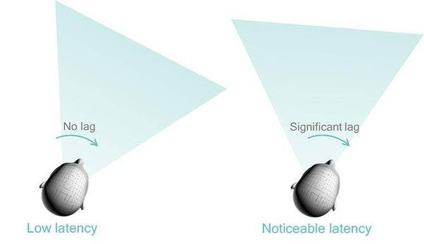

Figure 4.1 Latency and lag

* + Software development for various platforms means requirement of various different frameworks and knowledge.
  + Accuracy of accelerometer, magnetometer and gyroscope may vary from device to device.

**4.2 Safety Issues**

The hardware should be treated carefully as extensive damage to the hardware might hinder the end user experience, functionality of the VR car might also be affected because of the damage. Driving very fast while wearing the VR headset might induce dizziness in the users body, hence longer sessions or sessions with very fast driving should be avoided.

**3.3 Security Issues**

Video Transmission over local networks might be a security issue if unsafe protocols used. Usage on public networks would be on users risk in case of breach of privacy.

1. **Milestones**

|  |  |
| --- | --- |
| **Milestone** | **Milestone Goal** |
| Concept Approval | Feasibility studies and basic system concepts have been approved by our mentor and further research into the project has started. |
| Requirement Review | Requirements details for the project are complete and further designing has started. |
| Design Review | Confirming that the design satisfies the project requirements and are capable to fully implement the system and are suitable for code input. |
| Test Plan | Test Plans are Adequate for the testing of all product features, are approved and are suitable for input to the development of test cases. |
| System Test | Software for the system has passed testing and is suitable for further input |
| Product Operational | The Software and Hardware are working the way they were indented too. |

Table 1: Major Milestones

**Glossary**

* Latency: Time taken for a single video frame to from the camera to display
* VR Headset: A virtual reality headset is a head-mounted device that provides virtual reality for the wearer. VR headsets are widely used with computer games but they are also used in other applications, including simulators and trainers. They comprise of a stereoscopic head-mounted display, stereo sound and head motion tracking sensors.
* Accelerometer: An accelerometer is a device that measures proper
* Arduino: Arduino is an open-source platform used for building electronics projects. Arduino consists of both a physical programmable circuit board (often referred to as a microcontroller) and a piece of software
* Gyroscope: A gyroscope is a device used for measuring or maintaining orientation and angular velocity. The gyroscope measure the rate of change of a particular axis at the current moment in time. This means that to keep track of our angle, we need to sum all of the rates of change over a given period of time. We're essentially looking for the integral of our gyro data.
* Virtual Reality: Virtual Reality is a computer-generated scenario that simulates a realistic experience. The immersive environment can be similar to the real world in order to create a lifelike experience grounded in reality or sci-fi.

**References**

[1] Yufeng Shan, UC Berkeley. Cross-Layer Techniques for Adaptive Video Streaming over Wireless Network 2005:2, 220–228

[2] Jingwei Huang, Zhili Chen, Duygu Ceylan, Hailin Jin. “6 DOF VR Videos with a 360 Camera”, March 18-22, 2017, Los Angeles, CA, USA 978-1-5090-6647-6/17

[3] Nadine E. Miner, Sharon Stansfield, “An Interactive Virtual Reality Simulation System for Robot Control and Operator Training”, Intelligent Systems and Robotics Center